DDG-2080S Industrial Online Electrical Conductivity Analyzer is a brand-new online intelligent digital instrument independently developed and manufactured by BOQU. This Electrical Conductivity analyzer communicates with the sensor through RS485(ModbusRTU), which has the characteristics of rapid communication and accurate data. Complete functions, stable performance, easy operation, low power consumption, safety and reliability are the outstanding advantages of this EC analyzer.
The Electrical Conductivity analyzer works with digital electrical conductivity sensor ,which can be widely used in industrial application such as thermal power generation, chemical industry, metallurgy, environmental protection, pharmaceutical, biochemical, food and tap water.

Technical Features
1) Extremely quickly and precision electrical conductivity sensor.
2) It's suitable for harsh application and free-maintenance,save cost.
3) Provide two ways of 4-20mA output for EC and temperature.
4) Digital EC Sensor provide precision and online measurement.
5) With data recording function,user easy to check history data and history curve.
Technical Specification
Specifications | Details
Name | Online Electrical Conductivity Analyzer
Shell | ABS plastic
Power Supply | 90 – 260V AC 50/60Hz
Output | Two 4-20mA output tunnels,RS485
Relay | 5A/250V AC 5A/30V DC
Size | 144×144×104mm
Weight | 0.9kg
Protocol | Modbus RTU
Range | 0~2000000.00 us/cm(0~2000.00 ms/cm)  0~80.00 ppt  0~9999.00 mg/L(ppm)  0~20.00MΩ  -40.0~200.0℃(dpends on sensor)
Accuracy | ±2%FS  ±0.5℃
Waterproof Level | IP65

Installation and Wiring
SIZE
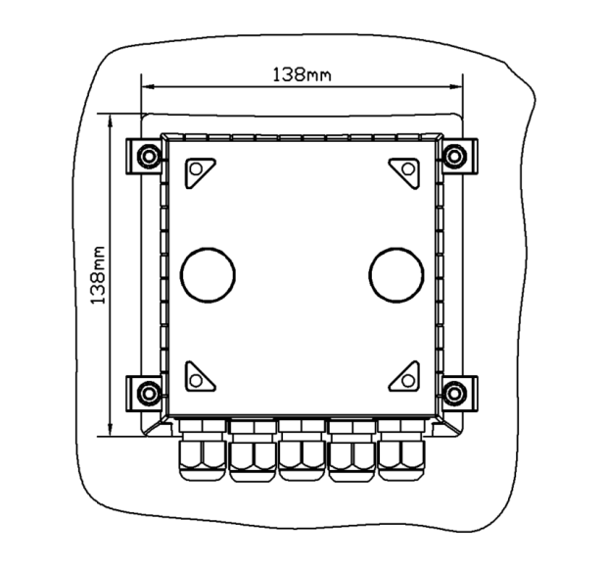
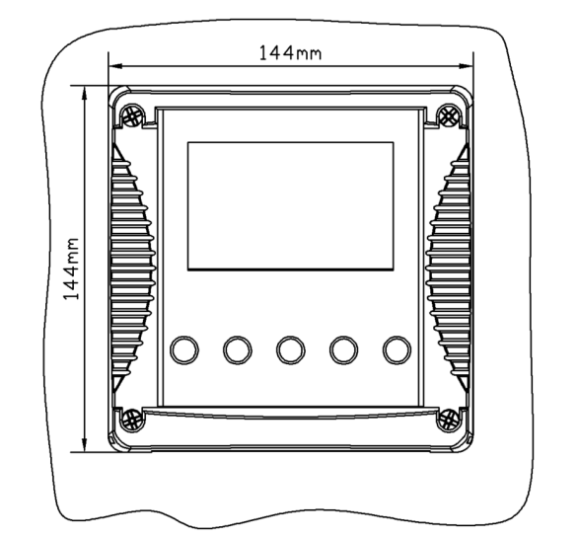

Installation
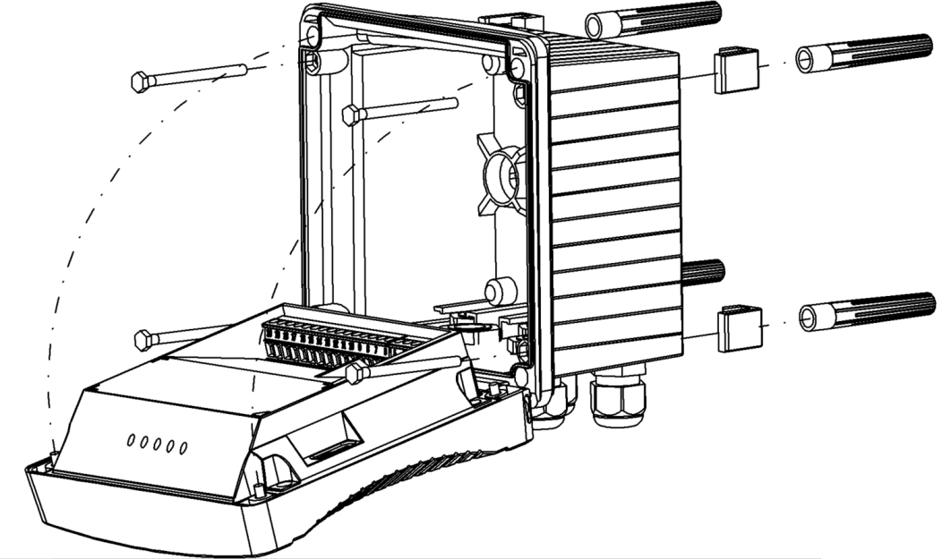

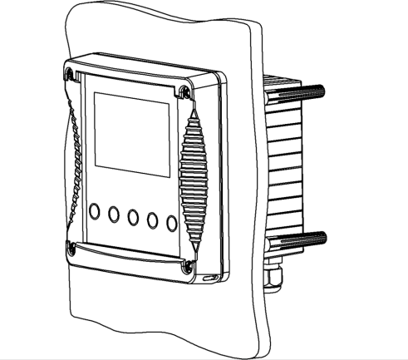
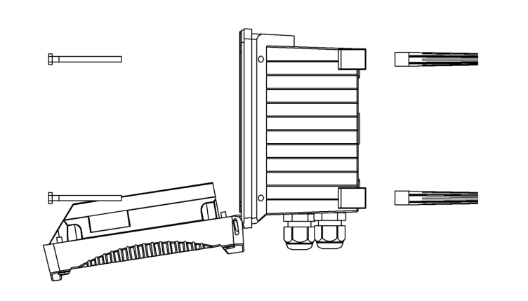

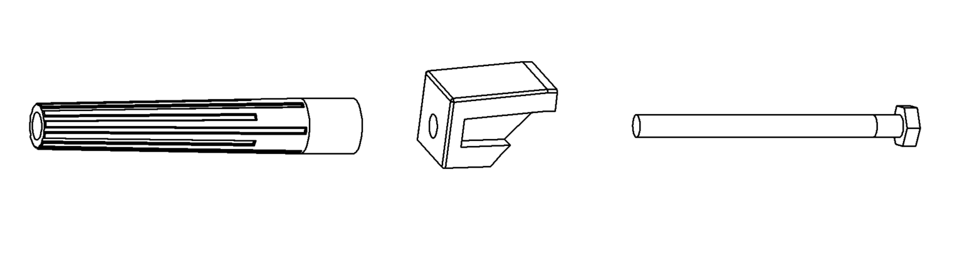

Wiring
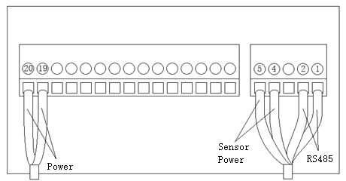
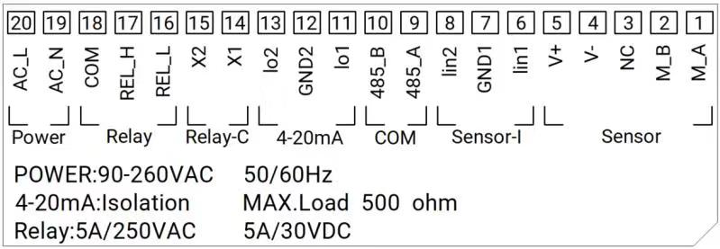

Operation Interface
There are 2 modules in the main panel of the electrical conductivity measuring instrument, LED LCD display module and button module.
Users can set and adjust the parameters of the instrument through the 5 buttons on the panel.
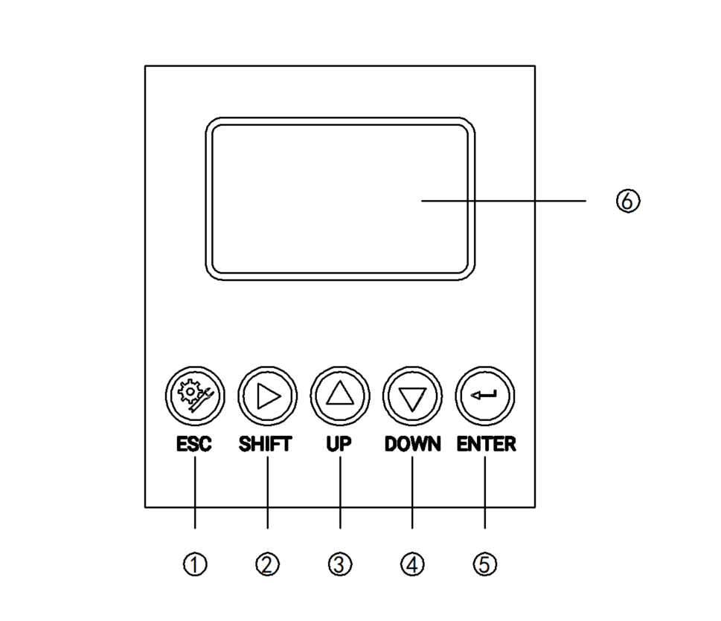
Picture 1 Operation Interface

- Set/Exit button
- Select/Shift button
- Up button
- Down button
- Confirm button
- LED screen
Measurement interface
Enter the main measurement interface after the start-up animation.
When the instrument is working normally, the LED display shows the following content.

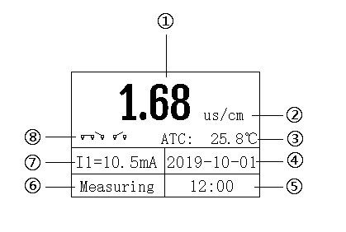
Picture 2 Main interface

- Measurement value
- Unit
- Temperature
- Real-time date
- Real time
- Measurement status
- 4-20mA corresponding value of electrical conductivity
- Relay status
Setting
Press “Set/Exit Button” to enter the password input interface.
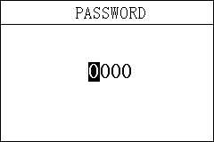
Picture 3 Password
Enter settings:
Enter the password "3700" to enter the setup menu.
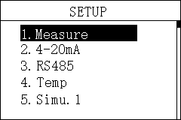
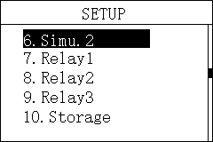
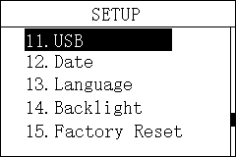
Picture 4 Setting Menu
3.1 Unit
In this menu, users can change the measurement method Cond / Salinity / TDS / Resistivity, and at the same time can adjust the offset to make the measurement accurate.
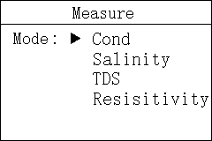
Picture 3.1.1 Uint
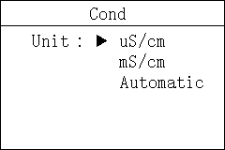
Picture 3.1.2 Unit

3.2 4-20mA
In this menu, users can change the corresponding value of 4-20mA and set the corresponding effective range.
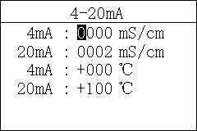
Picture 3.2 4-20mA

3.3 ModbusRTU communication
In this menu, users can change the communication address and rate.
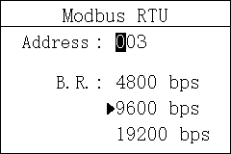
Picture 3.3 ModbusRTU communication
3.4 Temperature
In this menu, users can set the temperature offset and manually set the temperature.
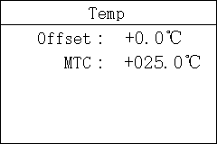
Picture 3.4 Temperature
3.5 Simulation
In this menu, users can simulate the 4-20mA current output. The current output can be verified by simulating the measurement of the IO1 (measured value) and IO2 (temperature) ports. The release relay is closed. The relay is simulated and verified.
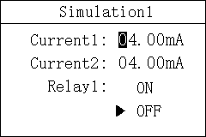
Picture 3.5.1 Simulation1
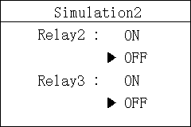
Picture 3.5.2 Simulation2

3.6 Relay1
In this menu, users can switch the relay 1 function, set the parameter alarm upper limit value, alarm return difference value, and alarm delay time.
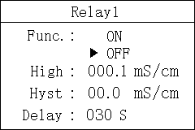
Picture 3.6 Relay1

3.7 Relay2
In this menu, users can switch the relay 1 function, set the parameter alarm upper limit value, alarm return difference value, and alarm delay time.
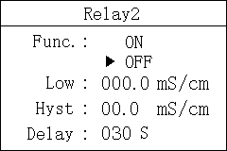
Picture 3.7 Relay2

3.8 Relay3
In this menu, users can set the relay 3 function, set the cleaning time and cleaning cycle.
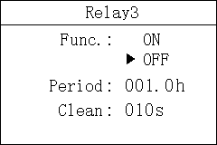
Picture 3.8 Relay3

3.9 Storage
In this menu, users can set the storage function (default on), clear storage memory and recording interval.
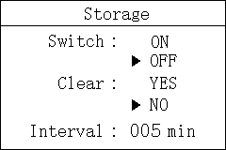
Picture 3.9 Storage

3.10 Date&Time
In this menu, users can change date and time according to different time zone.
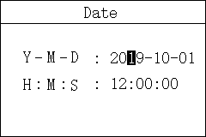
Picture 3.10 Date&Time
3.11 Language
Users can choose English or Chinese according to need.
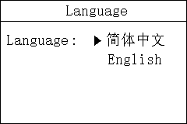
Picture 3.11 Language

3.12 Backlight
In this menu, users can change the backlight mode of the LCD screen. The backlight can be always on or delayed off (the default is delayed off), the backlight brightness can be changed (brightness level 1-5, brightness increases), and the contrast can be changed.
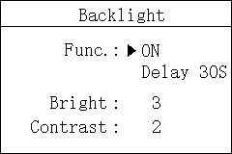
Picture 3.12 Backlight

3.13 Factory data reset
In this menu, users can restore the current output and relay to the factory parameters.
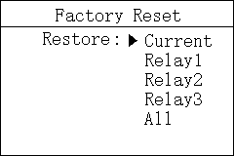
Picture 3.13 Factory data reset
Calibration
Press "ESC" to enter the password input interface.
Picture 5 Password
Enter calibration menu:
Enter the password "3900" to enter the calibration menu.
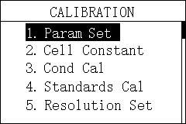
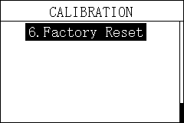
Picture 6 Calibration menu
4.1 Parameter set
In this menu, users can manually change the parameters of reference temperature and temperature coefficient.
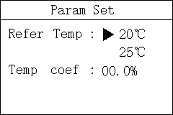
Picture 4.1 Parameter Set
4.2 Cell Constant
In this menu, users change cell constant manually . Press ‘Enter’ buttom after value changed.
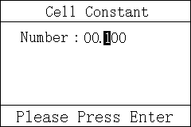
Picture 4.2 Cell Constant

4.3 Conductivity Calibration
In this menu, users can change conductivity by known density solution manually. Press ‘Enter’ buttom after value changed.
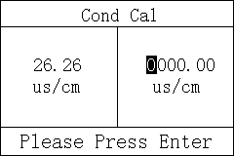
Picture 4.3 Conductivity Calibration
4.4 Standards Calibration
In this menu, users can change conductivity by standard solution. When the value comes stable, press ‘Enter’ buttom.
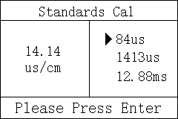
Picture 4.4 Standards Calibration

4.5 Resolution
In this menu, users can change resolution.

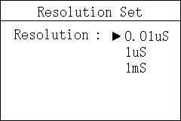
Picture 4.5 Resolution
4.6 Factory data reset
In this menu, users can restore the calibration parameters to the factory parameters.

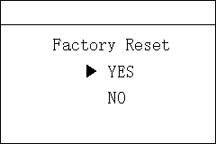
Picture 4.4 Factory data reset
History Data Display
Press "ESC" to enter the password input interface.

Picture 7 Password
Enter History Data Display:
Enter the password "1300" to enter the History Data Display.
Press the up and down keys to switch the display. It can store up to 1000 records and overwrite automatically if reach maximum.

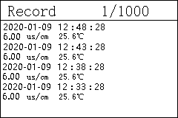
Picture 8 History

Waveform Display
Press "ESC" to enter the password input interface.

Picture 9 Password
Enter Waveform Display:
Enter the password "1400" to enter the Waveform Display.
Press the up and down keys to switch the display.
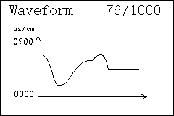
Picture 10 Waveform Display
Appendix
Communication protocol
Communication parameters:
Baudrate:4800, 9600, 19200(9600default)
Serial data format: 8N1(8 data bits, No parity, 1 stop bit)
Function code: 03
Device address: Electrical Conductivity analyzer defaults to 2
Register definition:
Register address(Dec) | Definition | R/W | Remarks
0，1 | Temp | R | ×1.0 ℃，FP32 AB CD
2，3 | EC | R | ×1.0 us/cm，FP32 AB CD
8 | RTU Address | R/W | Modbus communication address，EC defaults 2.
9 | Baudrate | R/W | 4800，9600，19200，9600 as default
26，27 | TDS | R | FP32 AB CD
28，29 | MoHM | R | FP32 AB CD
30，31 | ppt | R | FP32 AB CD

Examples of communication formats:
Data reading instruction
Addr. + Func. + Register start address + Number of Registers read + CRC check code (Hex)
e.g. Tx:02 03 00 02 00 02 65 F8
Address | Func. | Register start address | Number of Registers read | CRC check code
02 | 03 | 0002 | 0002 | 65F8
Data return instruction:
Address + Func. + Data length + Data + CRC check code (Hex)
e.g. Rx:02 03 04 40 0E B8 52 4E CD
Address | Func. | Data length | EC value | CRC check code
02 | 03 | 04 | 400EB852 | 4ECD
Convert the hexadecimal number 400EB852 to decimal through a floating-point number converter, resulting in a value of 2.23

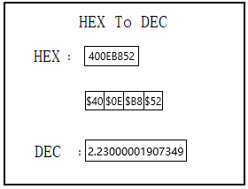

Electrode parameter table of Online Electrical Conductivity Analyzer
Type | BH-485-DD
CC | 0.01 | 0.1 | 1.0 | 10 | 30
EC Range | 0-20μS/cm | 0-200μS/cm | 0-2000μS/cm | 0-20000μS/cm | 30-600mS/cm
Temp Range | 0.0-100.0℃ | 0.0-100.0℃ | 0.0-100.0℃ | 0.0-100.0℃ | 0.0-100.0℃
Accuracy | 2%，±0.5℃
Withstand pressure | 0.4MPa
Waterproof Level | IP68/NEMA6P

